PostgreSQL server Advanced 3

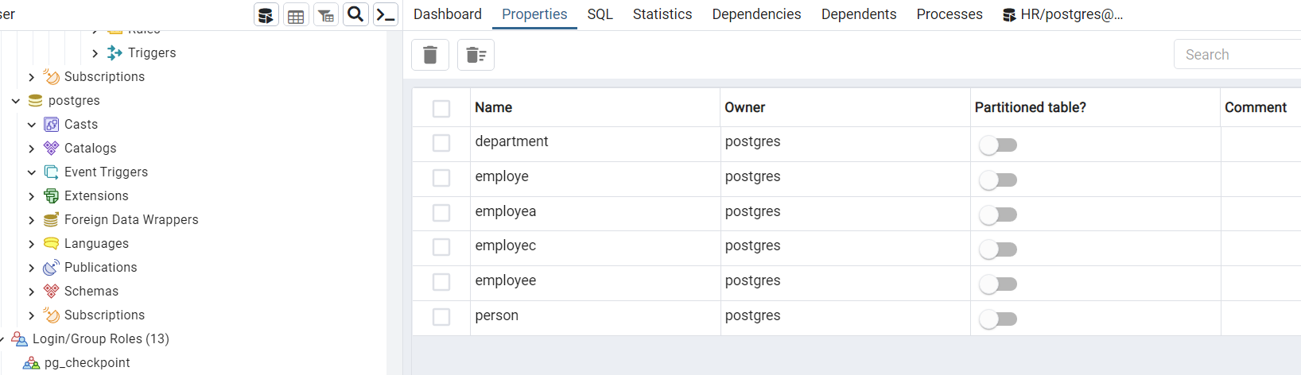

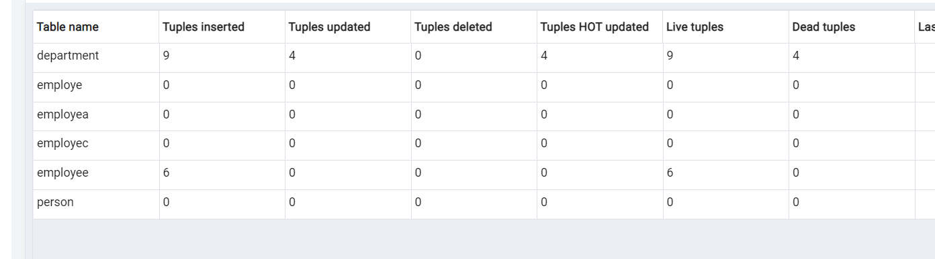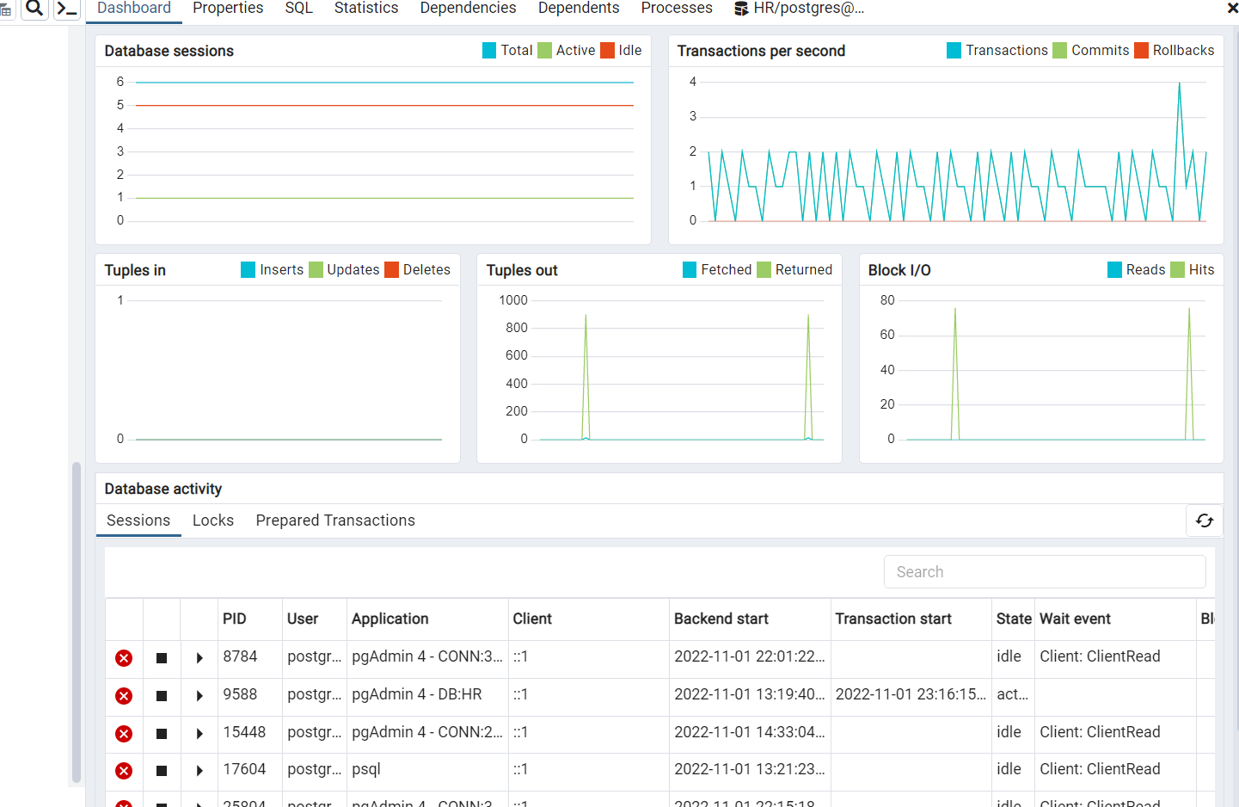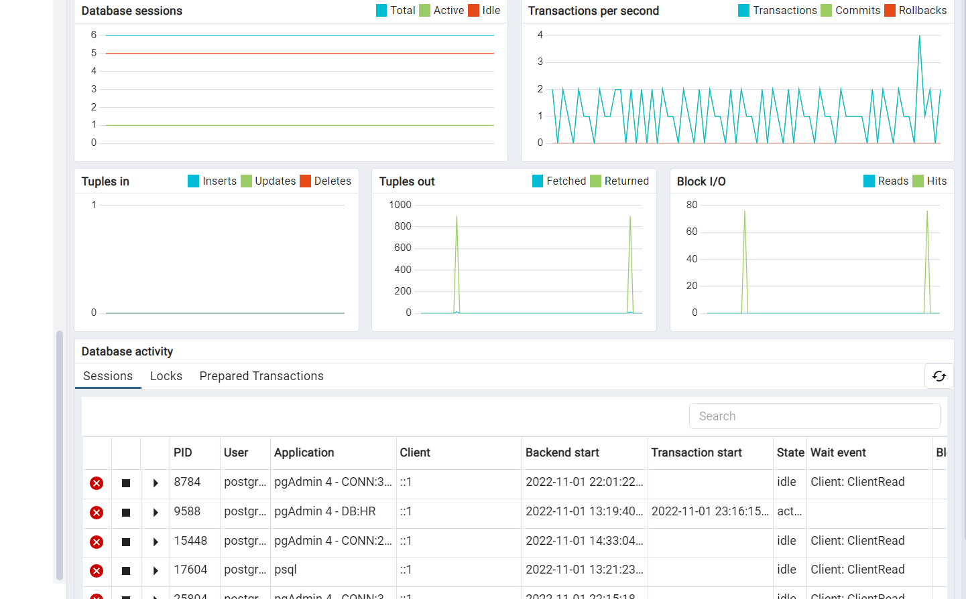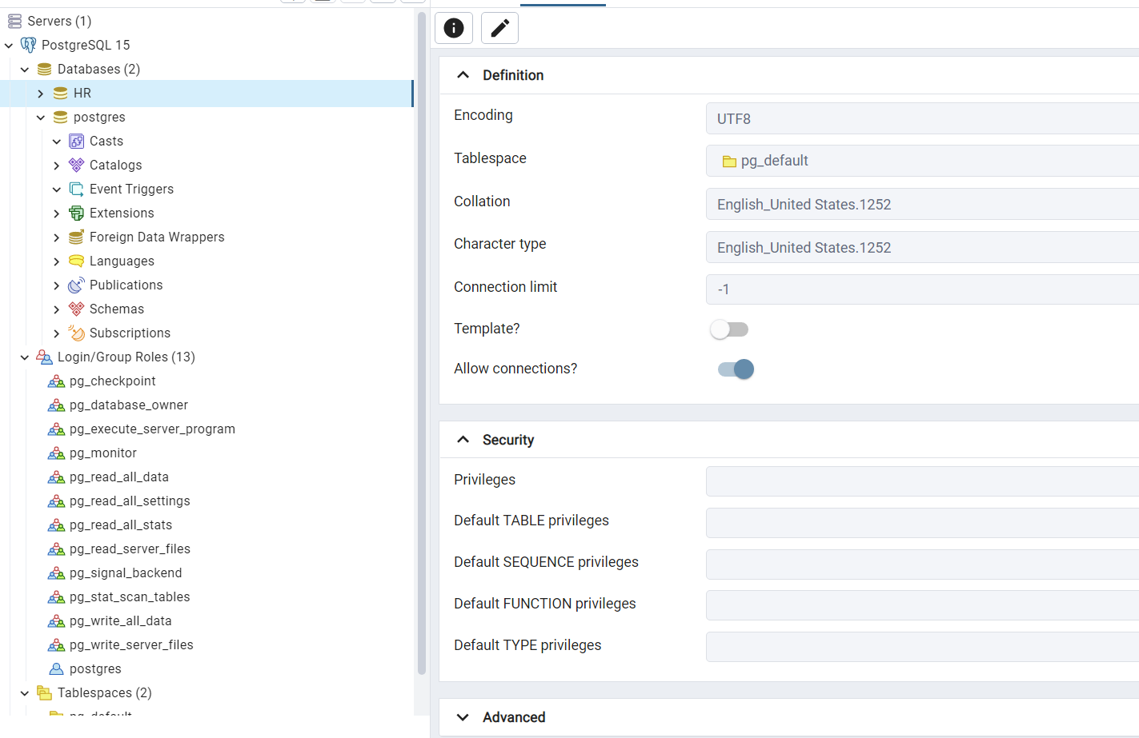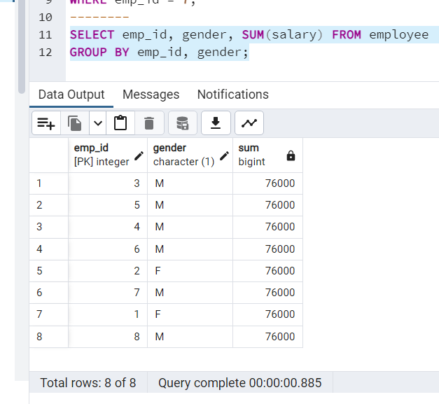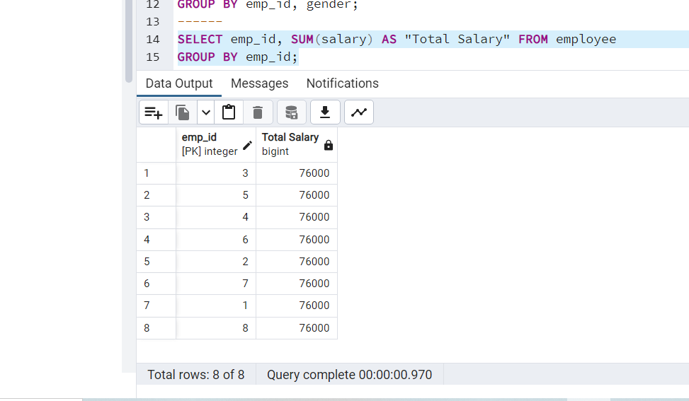

update table department set last_name='khan' where emp_id=9;

ERROR: syntax error at or near "table"

LINE 1: update table department set last_name='khan' where emp_id=9;

^

HR=# update department set last_name='khan' where emp_id=9;

UPDATE 1

HR=# \d employee;

Table "public.employee"

Column | Type | Collation | Nullable | Default

------------+------------------------+-----------+----------+-------------------------------------------

id | integer | | not null |

first_name | character varying(100) | | not null | 'ajman'::character varying

last_name | character varying(100) | | |

gender | character(1) | | not null | 'Male'::bpchar

bod | date | | |

salary | integer | | | 86000

country | character varying(50) | | | 'pakistan'::character varying

email | character varying(50) | | | 'ajman41288@gmail.com'::character varying

Indexes:

"empoly_info_pkey" PRIMARY KEY, btree (id)

"employee_unq" UNIQUE CONSTRAINT, btree (email)

HR=# select * from department;

emp_id | first_name | last_name | gender | birthdate | email | salary

--------+------------+-----------+--------+------------+---------------+--------

5 | Sachin | Tendulkar | M | 1978-01-09 | |

6 | Kapil | Dev | M | 1959-03-26 | |

7 | Joe | Root | M | 1988-11-29 | |

8 | Moeen | Ali | M | 1999-04-16 | |

10 | Kkhan | Dev | M | 1959-03-26 | |

11 | kahana | Root | M | 1988-11-29 | |

12 | Monib | Ali | M | 1999-04-16 | |

1 | Annie | Rizzolo | F | 1988-01-09 | ani@email.com | 0

9 | ajman | khan | M | 1978-01-09 | |

(9 rows)

HR=# select * from department;

emp_id | first_name | last_name | gender | birthdate | email | salary

--------+------------+-----------+--------+------------+---------------+--------

5 | Sachin | Tendulkar | M | 1978-01-09 | |

6 | Kapil | Dev | M | 1959-03-26 | |

7 | Joe | Root | M | 1988-11-29 | |

8 | Moeen | Ali | M | 1999-04-16 | |

10 | Kkhan | Dev | M | 1959-03-26 | |

11 | kahana | Root | M | 1988-11-29 | |

12 | Monib | Ali | M | 1999-04-16 | |

1 | Annie | Rizzolo | F | 1988-01-09 | ani@email.com | 0

9 | ajman | khan | M | 1978-01-09 | |

(9 rows)

HR=# update department set last_name='khan' ;

UPDATE 9

HR=# select * from department;

emp_id | first_name | last_name | gender | birthdate | email | salary

--------+------------+-----------+--------+------------+---------------+--------

5 | Sachin | khan | M | 1978-01-09 | |

6 | Kapil | khan | M | 1959-03-26 | |

7 | Joe | khan | M | 1988-11-29 | |

8 | Moeen | khan | M | 1999-04-16 | |

10 | Kkhan | khan | M | 1959-03-26 | |

11 | kahana | khan | M | 1988-11-29 | |

12 | Monib | khan | M | 1999-04-16 | |

1 | Annie | khan | F | 1988-01-09 | ani@email.com | 0

9 | ajman | khan | M | 1978-01-09 | |

(9 rows)

HR=# update department set email='hr@awesomecomp.com.pk' where emp_id<>1 ;

ERROR: duplicate key value violates unique constraint "department_email_key"

DETAIL: Key (email)=(hr@awesomecomp.com.pk) already exists.

HR=# update department set email='hr@awesomecomp.com.pk' where emp_id>=1 ;

ERROR: duplicate key value violates unique constraint "department_email_key"

DETAIL: Key (email)=(hr@awesomecomp.com.pk) already exists.

HR=# update department set salary=780000 where emp_id>=1 ;

UPDATE 9

HR=# select * from department;

emp_id | first_name | last_name | gender | birthdate | email | salary

--------+------------+-----------+--------+------------+---------------+--------

5 | Sachin | khan | M | 1978-01-09 | | 780000

6 | Kapil | khan | M | 1959-03-26 | | 780000

7 | Joe | khan | M | 1988-11-29 | | 780000

8 | Moeen | khan | M | 1999-04-16 | | 780000

10 | Kkhan | khan | M | 1959-03-26 | | 780000

11 | kahana | khan | M | 1988-11-29 | | 780000

12 | Monib | khan | M | 1999-04-16 | | 780000

1 | Annie | khan | F | 1988-01-09 | ani@email.com | 780000

9 | ajman | khan | M | 1978-01-09 | | 780000

(9 rows)

HR=# alter table department alter column email drop unique key;

ERROR: syntax error at or near "unique"

LINE 1: alter table department alter column email drop unique key;

^

HR=# alter table department alter column email drop unique ;

ERROR: syntax error at or near "unique"

LINE 1: alter table department alter column email drop unique ;

^

HR=# UPDATE employee

HR-# SET birthdate = NULL,

HR-# salary = 10000,

HR-# last_name = 'Blamire'

HR-# WHERE emp_id = 4

HR-# RETURNING *;

ERROR: column "emp_id" does not exist

LINE 5: WHERE emp_id = 4

^

HINT: Perhaps you meant to reference the column "employee.email".

HR=# UPDATE department set birthdate=null,salary=100000,last_name='Blamire' where emp_id=7 returning *;

emp_id | first_name | last_name | gender | birthdate | email | salary

--------+------------+-----------+--------+-----------+-------+--------

7 | Joe | Blamire | M | | | 100000

(1 row)

UPDATE 1

HR=# UPDATE deparment

HR-# SET last_name = 'Blamire',

HR-# birthdate = NULL,

HR-# salary = 10000

HR-# WHERE emp_id = 4

HR-# RETURNING first_name, last_name, salary;

ERROR: relation "deparment" does not exist

LINE 1: UPDATE deparment

^

HR=# UPDATE department

HR-# SET last_name = 'Blamire',

HR-# birthdate = NULL,

HR-# salary = 10000

HR-# WHERE emp_id = 4

HR-# RETURNING first_name, last_name, salary;

first_name | last_name | salary

------------+-----------+--------

(0 rows)

UPDATE 0

HR=# DELETE FROM department

HR-# WHERE emp_id = 7;

DELETE 1

HR=# select * from department;

emp_id | first_name | last_name | gender | birthdate | email | salary

--------+------------+-----------+--------+------------+---------------+--------

5 | Sachin | khan | M | 1978-01-09 | | 780000

6 | Kapil | khan | M | 1959-03-26 | | 780000

8 | Moeen | khan | M | 1999-04-16 | | 780000

10 | Kkhan | khan | M | 1959-03-26 | | 780000

11 | kahana | khan | M | 1988-11-29 | | 780000

12 | Monib | khan | M | 1999-04-16 | | 780000

1 | Annie | khan | F | 1988-01-09 | ani@email.com | 780000

9 | ajman | khan | M | 1978-01-09 | | 780000

(8 rows)

HR=# DELETE FROM department where emp_id in (10,11,12);

DELETE 3

HR=# select * from department;

emp_id | first_name | last_name | gender | birthdate | email | salary

--------+------------+-----------+--------+------------+---------------+--------

5 | Sachin | khan | M | 1978-01-09 | | 780000

6 | Kapil | khan | M | 1959-03-26 | | 780000

8 | Moeen | khan | M | 1999-04-16 | | 780000

1 | Annie | khan | F | 1988-01-09 | ani@email.com | 780000

9 | ajman | khan | M | 1978-01-09 | | 780000

(5 rows)

HR=# delete employee;

ERROR: syntax error at or near "employee"

LINE 1: delete employee;

^

HR=# delete table employee;

ERROR: syntax error at or near "table"

LINE 1: delete table employee;

^

HR=# CREATE TABLE employee (

HR(# emp_id INT PRIMARY KEY,

HR(# first_name VARCHAR(50) NOT NULL,

HR(# last_name VARCHAR(50) NOT NULL,

HR(# gender CHAR(1),

HR(# birthdate DATE,

HR(# email VARCHAR(100) UNIQUE,

HR(# salary INT

HR(# );

CREATE TABLE

HR=# INSERT INTO employee

HR-# VALUES(1,'Annie','Smith','F', DATE '1988-01-09', 'ani@email.com',5000);

INSERT 0 1

HR=# INSERT INTO employee(emp_id, first_name, last_name, gender, birthdate, email, salary)

HR-# VALUES(1,'Annie','Smith','F', DATE '1988-01-09', 'ani@email.com',5000);

ERROR: duplicate key value violates unique constraint "employee_pkey"

DETAIL: Key (emp_id)=(1) already exists.

HR=# INSERT INTO employee (emp_id, first_name, last_name, gender, birthdate)

HR-# VALUES (2, 'Susan', 'Klassen', 'F', DATE '2002-03-26')

HR-# RETURNING *;

emp_id | first_name | last_name | gender | birthdate | email | salary

--------+------------+-----------+--------+------------+-------+--------

2 | Susan | Klassen | F | 2002-03-26 | |

(1 row)

INSERT 0 1

HR=# INSERT INTO employee (emp_id, first_name, last_name, gender, birthdate, email)

HR-# VALUES (3, 'May', 'Kaasman', 'M', '1994-07-09', 'mkaasman2@freewebs.com')

HR-# RETURNING emp_id;

emp_id

--------

3

(1 row)

INSERT 0 1

HR=# INSERT INTO employee (emp_id, first_name, last_name, gender, birthdate)

HR-# VALUES (4, 'Charlton', 'Duran', 'M', DATE '2010-10-02')

HR-# RETURNING emp_id AS EmployeeID;

employeeid

------------

4

(1 row)

INSERT 0 1

HR=# INSERT INTO employee(emp_id, first_name, last_name, gender, birthdate)

HR-# VALUES

HR-# (5,'Sachin','Tendulkar','M', DATE '1978-01-09'),

HR-# (6,'Kapil', 'Dev', 'M', DATE '1959-03-26'),

HR-# (7,'Joe','Root','M', DATE '1988-11-29'),

HR-# (8,'Moeen', 'Ali', 'M', DATE '1999-04-16');

INSERT 0 4

HR=# INSERT INTO employee(emp_id, first_name, last_name, gender, birthdate)

HR-# VALUES

HR-# (5,'Sachin','Tendulkar','M', DATE '1978-01-09'),

HR-# (6,'Kapil', 'Dev', 'M', DATE '1959-03-26'),

HR-# (7,'Joe','Root','M', DATE '1988-11-29'),

HR-# (8,'Moeen', 'Ali', 'M', DATE '1999-04-16')

HR-# RETURNING *;

ERROR: duplicate key value violates unique constraint "employee_pkey"

DETAIL: Key (emp_id)=(5) already exists.

HR=# select * from employee;

emp_id | first_name | last_name | gender | birthdate | email | salary

--------+------------+-----------+--------+------------+------------------------+--------

1 | Annie | Smith | F | 1988-01-09 | ani@email.com | 5000

2 | Susan | Klassen | F | 2002-03-26 | |

3 | May | Kaasman | M | 1994-07-09 | mkaasman2@freewebs.com |

4 | Charlton | Duran | M | 2010-10-02 | |

5 | Sachin | Tendulkar | M | 1978-01-09 | |

6 | Kapil | Dev | M | 1959-03-26 | |

7 | Joe | Root | M | 1988-11-29 | |

8 | Moeen | Ali | M | 1999-04-16 | |

(8 rows)

HR=# SELECT *

HR-# FROM employee

HR-# WHERE first_name = 'Charlton';

emp_id | first_name | last_name | gender | birthdate | email | salary

--------+------------+-----------+--------+------------+-------+--------

4 | Charlton | Duran | M | 2010-10-02 | |

(1 row)

HR=# SELECT * FROM employee

HR-# WHERE salary > 50000;

emp_id | first_name | last_name | gender | birthdate | email | salary

--------+------------+-----------+--------+-----------+-------+--------

(0 rows)

HR=# SELECT * FROM employee

HR-# WHERE emp_id IN (1,6);

emp_id | first_name | last_name | gender | birthdate | email | salary

--------+------------+-----------+--------+------------+---------------+--------

1 | Annie | Smith | F | 1988-01-09 | ani@email.com | 5000

6 | Kapil | Dev | M | 1959-03-26 | |

(2 rows)

HR=# SELECT * FROM employee

HR-# WHERE gender = 'F' AND salary > 50000;

emp_id | first_name | last_name | gender | birthdate | email | salary

--------+------------+-----------+--------+-----------+-------+--------

(0 rows)

HR=# SELECT * FROM employee where WHERE gender = 'M' AND salary >= 50000;

ERROR: syntax error at or near "WHERE"

LINE 1: SELECT * FROM employee where WHERE gender = 'M' AND salary ...

^

HR=# SELECT * FROM employee where WHERE gender = 'F' AND salary >= 50000;

ERROR: syntax error at or near "WHERE"

LINE 1: SELECT * FROM employee where WHERE gender = 'F' AND salary ...

^

HR=# SELECT * FROM employee

HR-# WHERE gender = 'F' OR salary > 50000;

emp_id | first_name | last_name | gender | birthdate | email | salary

--------+------------+-----------+--------+------------+---------------+--------

1 | Annie | Smith | F | 1988-01-09 | ani@email.com | 5000

2 | Susan | Klassen | F | 2002-03-26 | |

(2 rows)

HR=# SELECT * FROM employee

HR-# WHERE gender = 'F' AND salary > 50000;

emp_id | first_name | last_name | gender | birthdate | email | salary

--------+------------+-----------+--------+-----------+-------+--------

(0 rows)

HR=# SELECT gender FROM employee GROUP BY gender;

gender

--------

M

F

(2 rows)

HR=# SELECT gender, COUNT(emp_id) FROM employee GROUP BY gender;

gender | count

--------+-------

M | 6

F | 2

(2 rows)

HR=# update employee set salary=76000;

UPDATE 8

HR=# select gender,sum(salary) from employee group by gender;

gender | sum

--------+--------

M | 456000

F | 152000

(2 rows)

HR=# SELECT dept_id, gender, SUM(salary) FROM employee

HR-# GROUP BY dept_id, gender;

ERROR: column "dept_id" does not exist

LINE 1: SELECT dept_id, gender, SUM(salary) FROM employee

^

HINT: Perhaps you meant to reference the column "employee.emp_id".

HR=#

